Core Concepts
- Probe (Prob): A mechanism that continuously monitors an application or container to determine its state and trigger actions such as restarts or traffic routing decisions.
- Health Probes in Kubernetes: liveness checks if a container should be restarted, readiness checks if it can serve traffic, and startup ensures slow-starting apps aren’t killed prematurely.
  - Liveness Probe: Checks if the application is alive. If it fails repeatedly, Kubernetes restarts the application container repeatedly, to try recover from transient errors. If doesn’t restart after attempts, finally throws error.
  - Readiness Probe: Ensures the application is ready to accept traffic before serving user requests. If the probe fails, the pod is removed from the load balancer to prevent serving traffic. Only when it passes, it will be added again.
  - Startup Probe: Additional probe used for slow-starting or legacy applications. It delays other probes until the application has fully started, allowing longer startup times before health checks begin. First startup probe is active, make sure it works, only then readiness and liveness probe will start.

Types of Health Checks Supported
Each probe type can perform either of 3 check methods:
Check Type | Description
HTTP GET | Sends an HTTP GET request to a specified endpoint and considers the pod healthy if a successful response is received.
TCP Socket | Attempts to open a TCP connection on a specified port. Health is based on the success or failure of opening the connection.
Command | Executes a specific command inside the container; success or failure is based on the command’s exit status.

Detailed Functionality & Examples
Configurable parameters:
    - initialDelaySeconds: Delay before starting the first check. eg wait for OS boot time, wait for dependencies or other tasks to finish, before app is expected to be ready.
    - periodSeconds: Interval between subsequent checks.
    - failureThreshold: Number of consecutive failures before marking the pod as unhealthy.
    - successThreshold: Number of consecutive successes to mark pod healthy again. Useful when: You want to avoid flapping (Pod marked Ready after one success but failing again immediately). You want stronger guarantees before routing traffic.
Liveness Probe:
  - Continuously monitors the container’s health after a specified initial delay.
  - If the health check fails (e.g., file missing, HTTP 500 error, port closed), Kubernetes restarts the container.
Readiness Probe:
  - Determines if the pod is ready to serve traffic.
  - Unlike the liveness probe, failed readiness checks do not restart the pod; they just prevent traffic routing to the pod.
  - Ensures load balancers send traffic only to healthy pods.
  - Syntax is similar to liveness probes but uses the readinessProbe field.
  - Example: uses HTTP GET on a specific path and port; if the endpoint is unavailable, the pod is marked as not ready.
Startup Probe:
  - Useful for slow-starting applications.
  - Keeps Kubernetes from marking the pod as unhealthy prematurely by delaying liveness and readiness probes until startup completes.

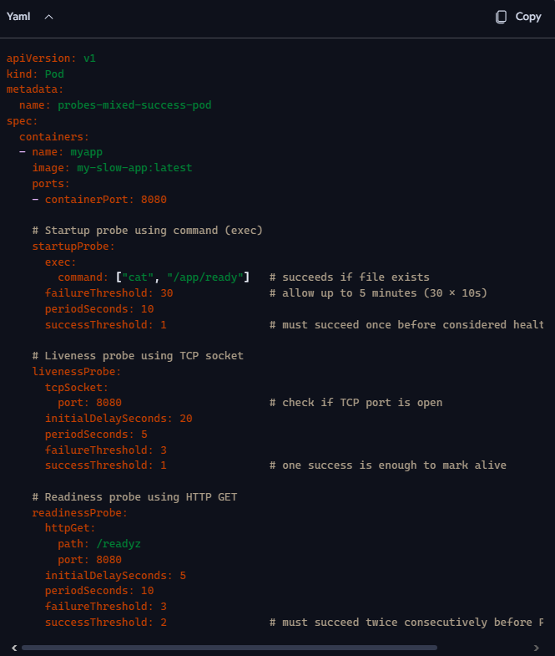

Example:
StartupProbe (exec): Runs cat /app/ready. If the file exists, startup is considered successful. Until then, liveness/readiness are disabled.
LivenessProbe (tcpSocket): Ensures the app is still listening on port 8080. If not, container is restarted.
ReadinessProbe (httpGet): Calls /readyz endpoint. If it fails, Pod is removed from Service endpoints (no traffic routed).

Startup probe protects slow initialization. Liveness probe ensures the app hasn’t hung. Readiness probe ensures traffic only flows when the app is truly ready.
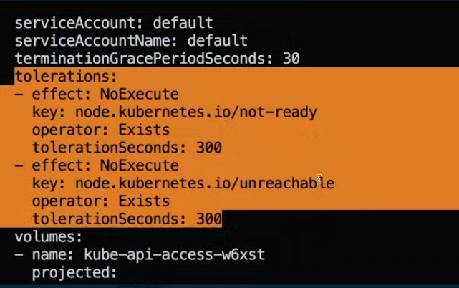

Kubernetes automatically adds NoExecute taints to nodes when they become unhealthy:
Condition | Taint Added
NotReady | node.kubernetes.io/not-ready:NoExecute
Unreachable | node.kubernetes.io/unreachable:NoExecute
These taints are added by the Node Controller when it detects that a node is not responding or is unhealthy.
Node becomes NotReady or Unreachable.
- Node Controller adds a NoExecute taint.
- Kubelet checks each Pod:
- If Pod does not tolerate the taint → evicted immediately.
- If Pod tolerates the taint with tolerationSeconds → evicted after timeout.
- If Pod tolerates the taint without timeout → never evicted.

Summary Table: Probe Characteristics
Probe Type | Action on Failure | Typical Use Case | Key Parameters
Liveness | Restarts container | Detect and recover from application crashes | initialDelaySeconds, periodSeconds, failureThreshold, successThreshold
Readiness | Removes pod from service traffic | Prevents traffic until pod is ready | Same as liveness, but no restarts
Startup | Delays readiness and liveness probes | Long startup time or legacy applications | Configurable delay before other probes

Key Insights
- Health probes ensure Kubernetes workload self-healing and traffic management, crucial for production-grade deployments.
- Combination of startup, readiness, and liveness probes provides fine-grained control over pod lifecycle and traffic flow.
- Understanding probe parameters and types of checks helps avoid premature restarts and downtime.
- Proper configuration of initial delays and thresholds is essential to accommodate application startup and transient failures.
- Kubernetes handles node failures automatically by adding tolerations to pods ensuring high availability.

